Below is a table disseminated by the California Department of Motor Vehicles. The table describes the level of Blood Alcohol Content (BAC) for individuals of different sexes (male and female), different weights (100 – 240 lbs) and how many drinks they’ve had (0 – 5). The legal limit for BAC is 0.08. Anything higher than that, it is illegal to drive.

1. Find the cell that corresponds to **your sex** (if you don’t identify with either of the sexes presented you could average the two cells male vs. female or flip a coin to pick one), and **your weight** (to the closest 20 lbs). Consider the case where you had 4 drinks. **Circle the cell in the table that corresponds to this BAC (your gender, weight, 4 drinks).**

Sex:__________ Weight:__________ BAC:______________

Based on this table, if you had to guess your BAC if you had 4 drinks, what would you guess it would be?

**Guess:________________**

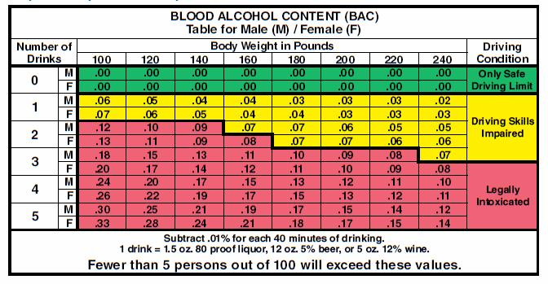

Notice at the bottom of the table, there is a statement which says **“Fewer than 5 persons out of 100 will exceed these values.”**

These values aren’t averages! They are the 95% percentile of a distribution. In this exercise we’ll backwards engineer what the actual distribution might look like. We’ll assume the distribution of BAC is normal with a standard deviation of 0.02.

1. Even among people who are your sex, your weight, and drink 4 drinks, not everyone will have the exact same BAC. People have different metabolisms, eat different amounts, have higher or lower blood pressure, so there will be variability! Consider the statement “Fewer than 5 persons out of 100 will exceed these values.” Mark on the distribution (last page) the point at which **5% of the distribution lays above that point.** There are marks to indicate where different proportions of the distribution lay.

**What is the Z-score for that point? ______________**

1. **Mark your value (from Question 1) on the BAC line, below the Z-score you found.** When you calculate the Z-score for your value of BAC you get your answer from Question 2. Below is the equation for a Z-score. Plug in all the information that you know. Remember, the standard deviation of BAC is 0.02

Write out the equation with what you know (Z, $Y_{i}$, and s)

$$Z=\frac{Y_{i}- \overline{Y}}{s}$$

1. The only unknown in the equation above is the mean $\overline{Y}.$ Solve the equation for $\overline{Y}$ in the space below. Mark on your distribution below the mean of the distribution of BAC. Write a short interpretation of what $\overline{Y}$ is.
2. If we modelled BAC using the mean (i.e., $Y_{i}= \hat{Y}+e_{i}$), what would your best guess for your BAC to be if you had 4 drinks? (i.e., What would $\hat{Y}$ be?) Is this answer the same as your answer from Question 1? Explain.
3. It’s illegal to drive with a BAC of more than 0.08. When you’ve had 4 drinks, it seems very likely your BAC will be over 0.08. Let’s figure out what that probability is. To do this we need to follow a few steps:
4. First, let’s **find the Z-score** which corresponds to 0.08 on the BAC scale. Use the equation $Z=\frac{Y_{i}- \overline{Y}}{s}$. Put your calculations below. **Mark this point on the distribution below.**
5. Based on where 0.08 falls in the distribution, make a guess about the probability that your BAC will be greater than 0.08.
6. To find the exact probability use the following R command (xpnorm(VALUE, mean = 0, sd = 1)). Plug in the Z-score you found where it says VALUE. What the probability is that your BAC will be above 0.08 if you have 4 drinks?

Probability:____________

**Z = 0**

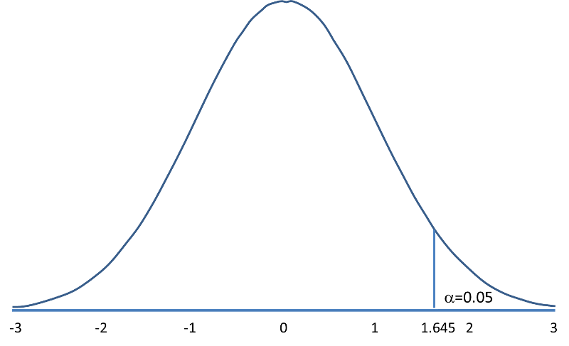

**Z = -1**

**Z = -1.645**

**Z = 1.645**

**Z = 1**

0.16

0.50

0.50

0.16

0.05

**BAC**